MATRIX VECTOR MULTIPLICATION

SOURCE CODE:

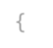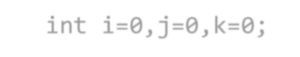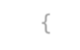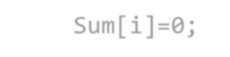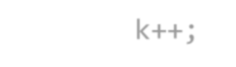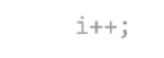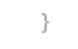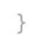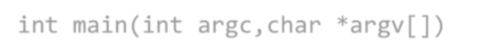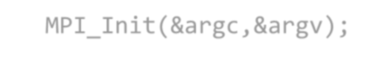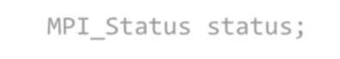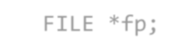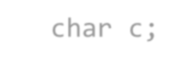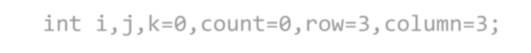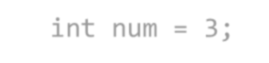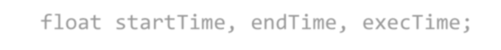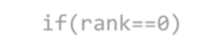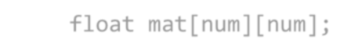

#include<stdio.h>

#include<stdlib.h> #include<mpi.h>

void multi(int Count,float *Sum,float Vec[],float Data[],int Column)

{

int i=0,j=0,k=0; while(i<Count)

{

Sum[i]=0; for(j=0;j<Column;j++)

{

Sum[i] = Sum[i] + Data[k] * Vec[j]; k++;

} i++;

}

}

int main(int argc,char *argv[])

{

int rank,size,*sendcount,*displace,*reccount; MPI_Init(&argc,&argv); MPI_Comm_size(MPI_COMM_WORLD,&size); MPI_Comm_rank(MPI_COMM_WORLD,&rank); MPI_Status status;

FILE *fp; char c;

int i,j,k=0,count=0,row=3,column=3; int num = 3;

float n=0,*sum,*rec_data,*data,*vec; float startTime, endTime, execTime;

sendcount = (int*)calloc(sizeof(int),size); reccount = (int*)calloc(sizeof(int),size); displace = (int*)calloc(sizeof(int),size); if(rank==0)

{

float mat[num][num];

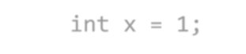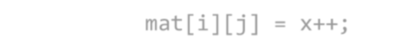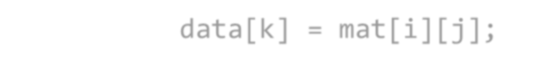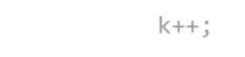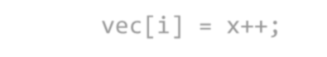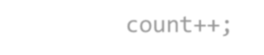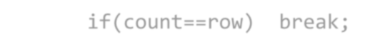

data = (float*)calloc(sizeof(float),num*num);

vec = (float*)calloc(sizeof(float),num); int x = 1;

for(i=0;i<num;i++)

{

for(j=0;j<num;j++)

{

mat[i][j] = x++;

data[k] = mat[i][j]; k++;

}

}

for(i=0;i<column;i++)

{

vec[i] = x++;

}

startTime = MPI_Wtime(); while(1)

{

for(i=0;i<size;i++)

{

sendcount[i] = sendcount[i]+1; count++;

if(count==row) break;

}

if(count==row) break;

}

for(i=1;i<size;i++)

{

displace[i] = displace[i-1] + sendcount[i-1]*column; sendcount[i-1] = sendcount[i-1] * column;

}

sendcount[size-1] = sendcount[size-1] * column;

}



MPI_Bcast(&row,1,MPI_INT,0,MPI_COMM_WORLD);

MPI_Bcast(&column,1,MPI_INT,0,MPI_COMM_WORLD);



if(rank!=0)

{

//data=(float*)calloc(sizeof(float),row*column); vec = (float *)malloc(sizeof(float) * column);

}



MPI_Bcast(vec,column,MPI_FLOAT,0,MPI_COMM_WORLD);

MPI_Bcast(sendcount,size,MPI_INT,0,MPI_COMM_WORLD); MPI_Bcast(displace,size,MPI_INT,0,MPI_COMM_WORLD);



rec_data=(float*)calloc(sizeof(float),sendcount[rank]);



//MPI_Bcast(data,row*column,MPI_INT,0,MPI_COMM_WORLD);

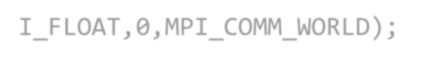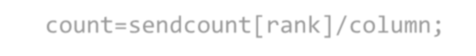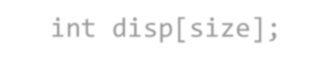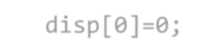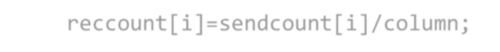

MPI_Scatterv(data,sendcount,displace,MPI_FLOAT,rec_data,sendcount[rank],MP

I_FLOAT,0,MPI_COMM_WORLD);

count=sendcount[rank]/column; sum=(float*)calloc(sizeof(float),count); multi(count,sum,vec,rec_data,column);

float *result=(float *)calloc(sizeof(float),row); int disp[size];

disp[0]=0; reccount[0]=sendcount[0]/column; for(i=1;i<size;i++)

{

disp[i] = disp[i-1] + sendcount[i-1]/column; reccount[i]=sendcount[i]/column;

}

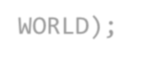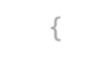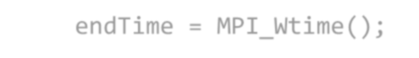

MPI_Gatherv(sum,count,MPI_FLOAT,result,reccount,disp,MPI_FLOAT,0,MPI_COMM_

WORLD);

if(rank==0)

{

endTime = MPI_Wtime();



printf("\nMatrix Vector Multiplication is:\n");

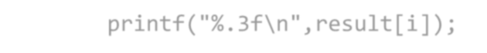

for(i=0;i<row;i++)

{

printf("%.3f\n",result[i]);

}

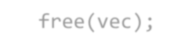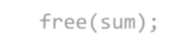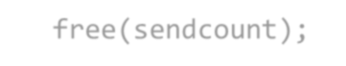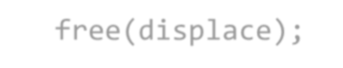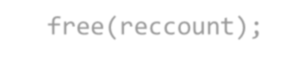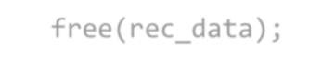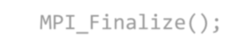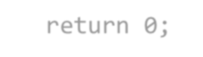

printf("\nExecution Time is %f\n",endTime-startTime);

}

free(vec); free(sum); free(sendcount); free(displace); free(reccount); free(rec_data); MPI_Finalize();

return 0;

}